AWS SysOps Administrator- Associate Level

**Setting up a website on Cloud**

Course-end Project 2

1. Create an EC2 instance (OS: Windows 2012 R2 Base)

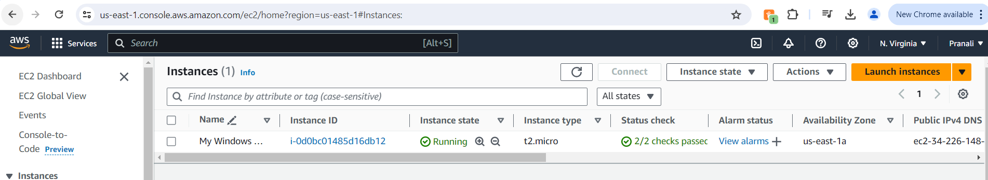

1. Install IIS server role

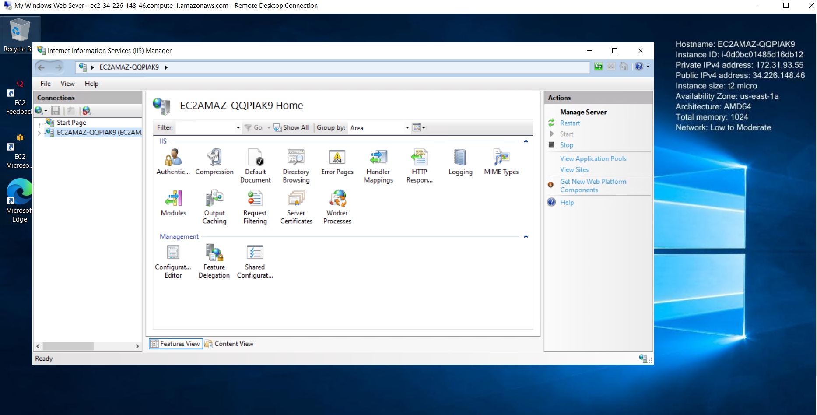

1. Create a static website and check on a localhost

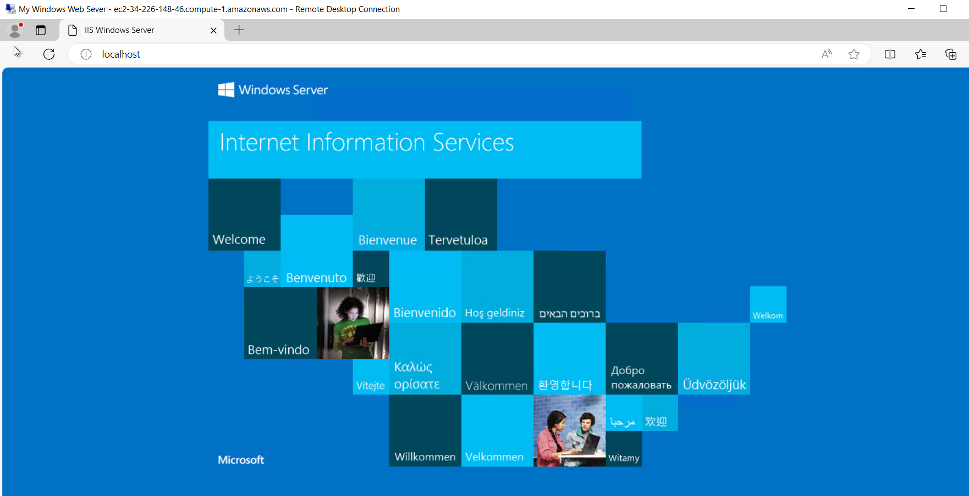

1. Create an image of the machine and save the AMI

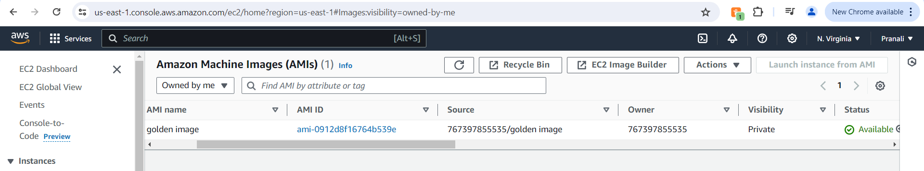

1. Create a new instance using the AMI you have saved

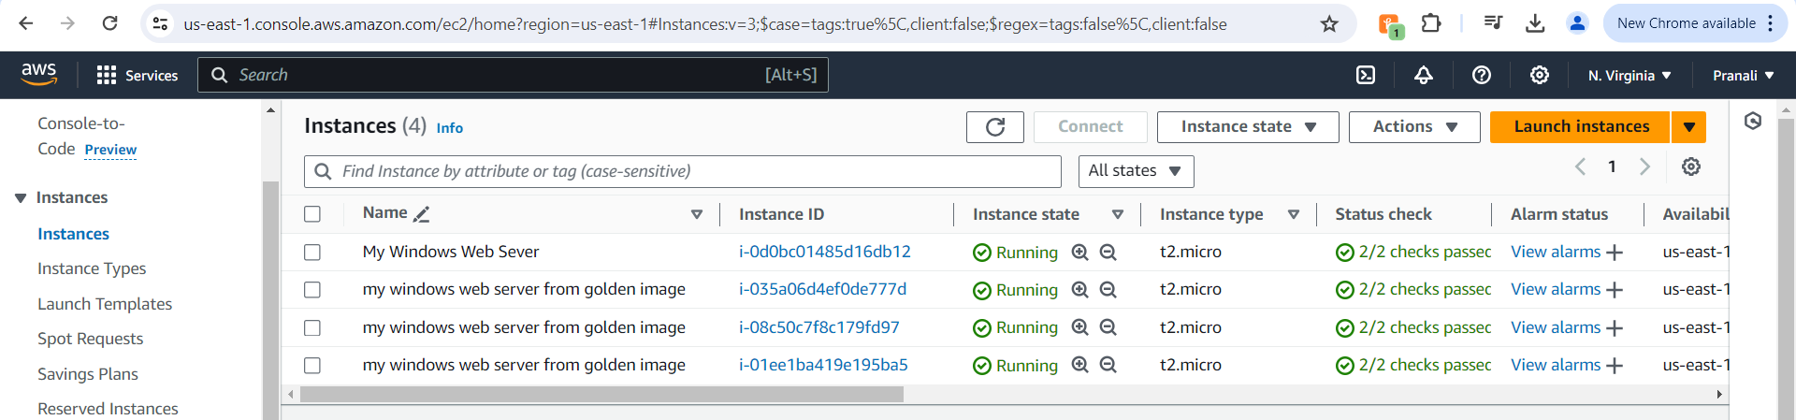

1. Create a Load Balancer and attach the instances you have done before

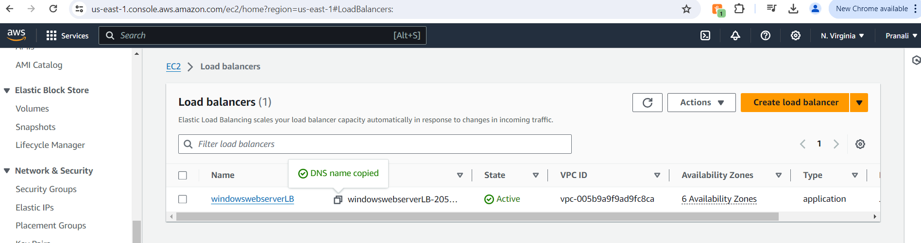

1. Check the DNS name on the browser

